Contents

Tools 3

HTML 3

*Visual Studio* 3

*Nova* 4

*Komodo Edit*  4

*Notepad ++*  5

*CSS* 6

*Gimp* 7

SVG 7

Browser 7

*Edge* 7

*Firefox* 7

*Chrome* 7

*Opera* 7

*Wave Browser* 7

Hardware 7

*Mini PC* 7

Techniques 8

*Trello* 8

*Kanban* 8

*Scrum* 9

Bibliography 10

**F**igure 1-Visual studio Logo 4

Figure 2-Visual studio code page 4

Figure 3 Nova logo 5

Figure 4 nova code page 5

Figure 5 Komodo edit Logo 5

Figure 6 Notepad ++ 6

Figure 7 notepad ++ code page 6

Figure 8 CSS logo 7

Figure 9 CSs external page 7

Figure 10 CSS internal code on an HTML page 7

Figure 11 GIMP logo 8

Figure 13 Mini PC Figure 14 tower PC 8

Figure 15 Trello logo 9

Figure 16 Kanban logo 9

Figure 17 scrum logo 10

**Unit33-1.3**

The tools & techniques I use for writing code for my web pages, are itemised below. There is a lot of information and practice required to enhance my web page code writing skills, this includes page design, code writing, formatting, image embedding, image design, testing code, testing web pages, hosting to the internet.

# Tools

## HTML

HTML is a markup language for writing code to format and edit text, used to form the content of web pages, it is not a programming language[1].

HTML deals with the visual interface of a web page (kj, HTML is in no way a programming language., 2022)

Visual Studio  Figure 1-Visual studio Logo

Microsoft visual studio is an integrated development environment, used to develop web pages, apps, and programs. The app uses Microsoft platforms [Windows API, Forms, Presentation, and store.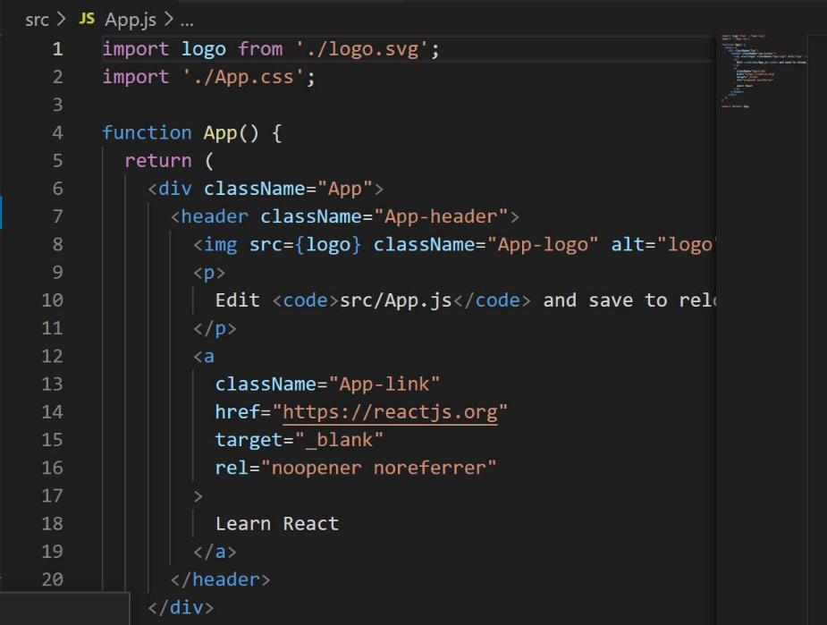

Figure 2-Visual studio code page

**“as the app is free source and there are no fees for using the app, it is my choice, and it can enable myself to write code and learn the process of building my own web pages.”**

Nova  Figure 3 Nova logo

Nova is the new name of CODA 2, the app is for use with Mac hardware devices, it is licensed source, meaning users must pay a fee to use the application.

Like visual studio, it has an editor for code, interface, workflows, tools, extensions and settings.

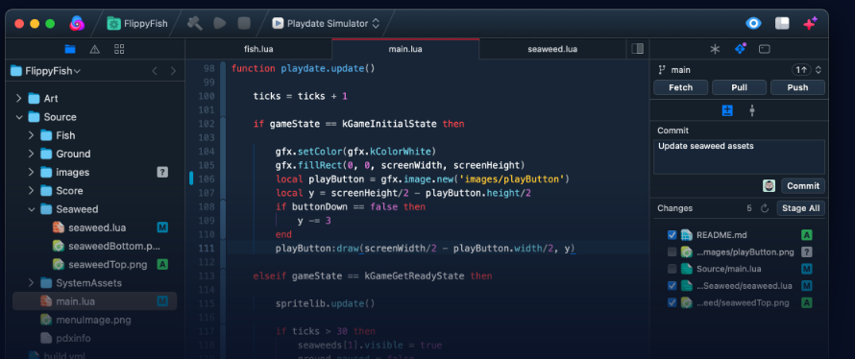

Figure 4 nova code page

Komodo Edit (kj, Komodo Edit, 2022)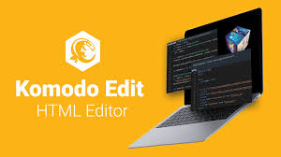 Figure 5 Komodo edit Logo

Code editor for open-source languages, free to use, the site includes languages such as;

* Python
* Perl
* HTML/CSS
* JavaScript

It also includes tools such as,

* Debugging [*finding faults with code*] during the writing process
* Unit testing

Notepad ++ 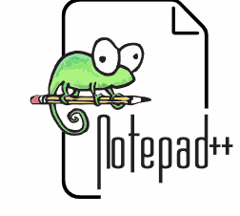 Figure 6 Notepad ++

Notepad ++, is a free to use it works with the windows platform, supports several languages, written in C++[2], allows working with multiple open files on a single page. Includes ad editor and testing features.

Figure 7 notepad ++ code page

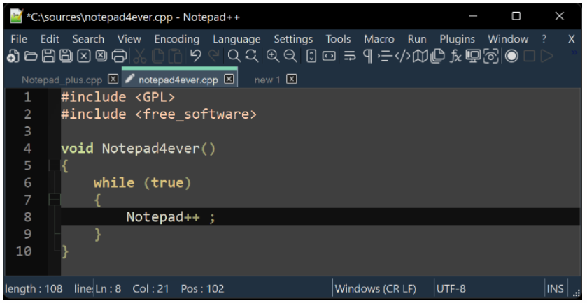

## *CSS*

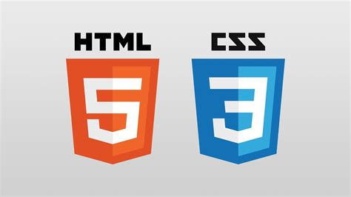 Figure CSS logo

Cascading Style Sheets, written in a markup language describing the presentation and layout of a document, a major element of the technology of the world wide web along with HTML and JavaScript.

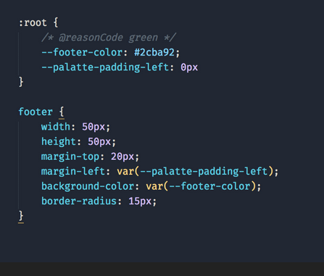 Figure CSs external page

Allows the user to format the layout of a web page, colours, and fonts. CSS can be an external page which allowed users to link the CSS code to multiple pages, or an internal set of code that organises code to a single page or part of a page.

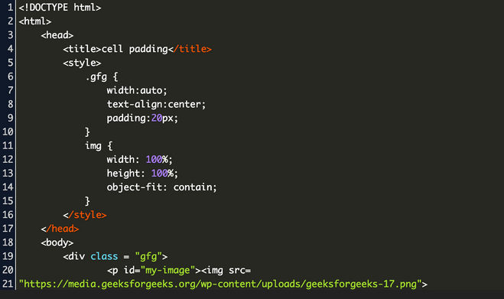 Figure CSS internal code on an HTML page

Figure GIMP logo

A free open-source raster[3] graphics editor, used to create images and manipulate existing images and photos for web pages and documents, users can create logos and feature images for documents and web pages such as buttons, links, watermarks, and graphics used to support text.

## SVG

Scalable vector[4] graphic file users can form two-dimensional images for use with web pages.

## Browser

Browsers are used mainly for searching information, also used to open web pages and test the different formatting allowed on individual browsers/servers, meaning code writers can choose a preferred server for their web pages.

### *Edge*

*“my choice of default browser, has plenty of features and is part of the Microsoft platform and therefore connected to windows, search, downloads, favourites, and tabs make the application easy to use”.*

### *Firefox*

Like Edge, it offers basically the same tools.

### *Chrome*

As above but gives good access to Google’s applications. *“I have started using Google Docs, mainly for the share feature, where I can edit a document with a fellow author to automatically create a unified document, where we share a opinion or agreement on information we want to relay”.*

### *Opera*

Like other servers, it offers all the tools a searcher requires, but does include a larger number of helpful apps.

### *Wave Browser*

Like Opera, includes all the tools needed to allow search.

## Hardware

Mini PC 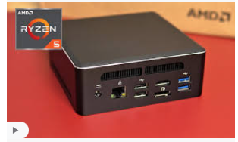 Figure 13 Mini PCA picture containing text, loudspeaker, computer

Description automatically generated Figure 14 tower PC

A smaller version of a desktop computer with a tower, portable, allows three monitors if the owners other devices are compatible with mini-PC’s interface [HDMI, USB ports, Ethernet].

Laptop

Portable, can run extra monitor, runs same programmes.

Tablet

More portable than a laptop, offers the same access to apps with limited scope.

Smart Phone

Essential tool in today’s world, can run apps as other devices, but limited viewing.

# Techniques

Figure 15 Trello logo

Like Kanban, uses a board as the background platform, portraying list of tasks to be carried out for a project from start to finish.

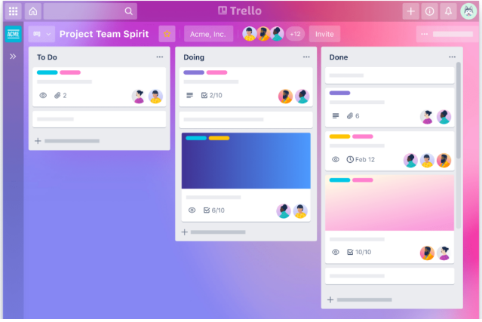

Kanban  Figure 16 Kanban logo

A popular framework used to implement agile development strategy. Requires team members to interact to discuss and delegate tasks and monitor progress. By using a visual representation, it is easier to identify weaknesses and positives, then adapt the teams progress to enable a more successful goal.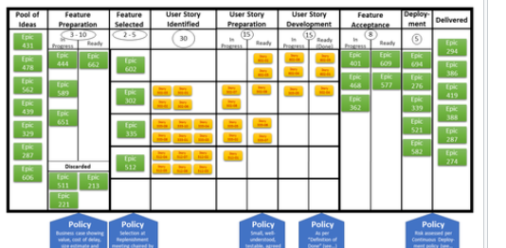

Scrum  Figure 17 scrum logo

A framework where team members can address complex problems, while creating and monitoring products, members need to actively participate in discussions with ideas and delegation.

<https://youtu.be/gy1c4_YixCo>

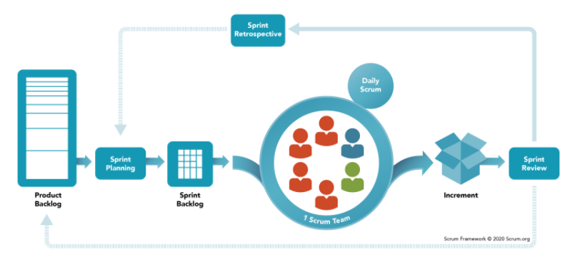

# Bibliography

kj. (2022, May 13). *HTML is in no way a programming language.* Retrieved from Is HTML considered a programming language?: https://stackoverflow.com/questions/145176/is-html-considered-a-programming-language

kj. (2022, May 13). *Komodo Edit*. Retrieved from Active state: https://www.activestate.com/products/komodo-ide/downloads/edit/

1. Programming languages deals with [*processing functions*] {**functions produce information**}
2. C++ was designed with an orientation toward [systems programming](https://en.wikipedia.org/wiki/Systems_programming) and embedding images
3. Raster graphics work well for highly detailed images like photographs
4. Vector-graphic formats images as a set of points and lines between points